Mostafa Ibrahim

Professor Carey

CPS 293

9/19/2024

Final Project Proposal

**Concept/Theme:**

The core concept for this game is a 2D survival horror experience, reminiscent of “Five Nights at Freddy's” (FNAF) and “Outlast”, with a unique twist on movement and strategic risk-reward mechanics. Players will explore a large, dimly lit environment using a flashlight that has a limited battery, creating a tense atmosphere. The gameplay revolves around managing battery life, avoiding enemies, and using cameras to scout the area. The setting will feature various levels with increasingly difficult enemy challenges, where players must navigate through locked or unlocked rooms to survive the night.

**General Idea:**

**Mechanics:**

**Flashlight & Battery System:**

The flashlight system is a core aspect of gameplay, crucial to the player’s survival in a dark and oppressive environment. The flashlight allows players to see their immediate surroundings, creating a small radius of light that pierces through the darkness. This limited field of vision forces the player to strategically manage both their movement and flashlight usage. The flashlight’s battery is finite, which means that careless use can lead to the player being plunged into complete darkness, making them highly vulnerable to enemy attacks.

The mechanic revolves around careful balancing—while keeping the flashlight on continuously provides safety and comfort, it also rapidly drains the battery. The player must decide when it’s most important to see and when it’s better to conserve battery life. Flashlight usage is directly linked to survival, as enemies typically lurk in dark corners of the map, unseen without light. There will be a visual indicator for battery life, warning players as the battery depletes and reaches dangerous levels.

To enhance the tension, players can find limited battery packs scattered across the map. However, these resources will be rare, forcing the player to explore and take calculated risks to prolong their light source. The scarcity of resources adds a layer of decision-making; do you explore a possibly dangerous area in search of more battery, or do you conserve power and attempt to survive in the dark? The gradual depletion of battery life also adds time pressure, as the game encourages efficient use of resources and quick, deliberate decision-making.

The presence of the flashlight also ties into the overall game aesthetic. The narrow beam of light will create stark contrasts between light and shadow, adding to the eerie atmosphere. This limited visibility intensifies the feeling of claustrophobia and fear, as players are often left uncertain about what lurks just beyond the light’s edge.

The safety of vision isn’t the only bright side to the flashlight. Shining the flashlight upon an enemy will cause them to slow down slightly to give the player a chance to escape. However using this feature also causes the player to take a risk in the levels that have more than one active enemy as the enemy may call for assistance or another enemy can come from the player’s blind spot ready to attack.

**Camera System:**

The camera system serves as the second major survival tool for the player, providing them with broader situational awareness but at a significant risk. Unlike the flashlight, which allows players to see only a small portion of the area directly around them, the cameras allow players to monitor multiple rooms remotely. However, the key trade-off lies in the fact that while using the cameras, the player cannot move or interact with their environment. This means the player becomes vulnerable to any approaching threats during camera use.

Each camera is equipped with night vision (NV), which enhances visibility in dark areas. This creates a risk-reward dynamic—while the player can scout distant areas for enemy movement, they are exposing themselves to danger as enemies may move towards their location while they’re absorbed in the camera feed. The animation required to open and close the camera system also adds tension, as players cannot instantaneously switch between looking at the camera and navigating their environment. This delay becomes a crucial factor in deciding when and where to use the cameras, as timing becomes everything in avoiding enemy detection.

The cameras are strategically placed throughout the game’s levels, covering different rooms but hallways will not have any cameras to scout with so making a move from room to room will be more crucial on how much flashlight battery gets used during each level. Learning the layout of the cameras and understanding their blind spots is critical to successful navigation and survival. Some cameras may be placed in more high-risk areas, requiring players to risk enemy encounters if they want to access a better view of the environment. As levels progress, the camera system will become even more vital, as enemies grow in number and complexity, and certain rooms become locked or unlocked.

In later levels, cameras may malfunction or become inaccessible, forcing players to rely more on their flashlight or memory of the environment. This encourages players to be strategic, thoughtful, and precise in their decisions when utilizing the camera system.

**Enemy Movement:**

Enemy movement plays a vital role in driving the tension and challenge in the game. In early levels, players will face a single enemy with a relatively simple patrol path, allowing them to get comfortable with the basic mechanics of flashlight management and camera use. As the game progresses, however, enemies become more numerous and their behaviors more complex. By Level 5, the player will face the maximum number of enemies, all with unique movement patterns and adaptive behaviors designed to increase difficulty and unpredictability.

Each enemy will have its own patrol route, but these routes won’t remain static for the entirety of a level. Enemies may change direction unexpectedly, patrol multiple areas, or be drawn to noises the player makes while moving or interacting with objects in the environment. This creates an element of unpredictability and forces players to constantly remain on their guard, never fully sure where an enemy might appear next.

Enemies are designed to react to the player’s actions. For example, using the flashlight too much in close proximity to an enemy may attract their attention causing them to start moving toward the player’s location if they are in that enemy’s active area of effect. Some enemies may be slower but able to detect players more easily, while others may be faster but rely more on having a line of sight to spot the player. This variety in enemy behavior ensures that players cannot rely on a single strategy for evasion and forces them to adapt their playstyle as new challenges emerge.

In the final levels, enemy count and movement complexity will increase dramatically. Enemies will begin to actively hunt the player, tracking their movements and seeking out hiding spots that the player has used frequently. The difficulty curve will escalate, requiring precise management of resources, quick decision-making, and a deep understanding of enemy behavior to survive.

**Hiding Mechanic:**

The hiding mechanic serves as a last-ditch option for players to evade enemies when direct confrontation or escape is impossible. Throughout the levels, players will encounter designated hiding spots where they can temporarily avoid enemy detection. However, the hiding system introduces a dynamic counterbalance to prevent overuse or over-reliance. Every time a player uses a hiding spot, a counter increases for that specific location, making it more likely that nearby enemies will check it during future patrols.

Hiding spots offer a brief respite but carry significant risks. In some cases, players will be forced to watch as an enemy looms near, unsure if they will be discovered or not. The proximity and behavior of the enemy when checking hiding spots are influenced by the player’s previous actions, such as how often they've used a particular hiding area or how close they were to an enemy when they decided to enter the hiding spot. This makes the hiding mechanic a short-term solution; over time, enemies become more suspicious and are more likely to investigate areas where they have seen or heard the player before.

The use of hiding spots also adds to the game's psychological tension. Players will often be faced with the choice of whether to risk a hiding spot they've used before or attempt to escape by other means. This constant sense of dread, wondering whether the chosen hiding spot is still safe, amplifies the fear factor. The decision to hide must be made carefully, as choosing the wrong time or place can result in an instant jump scare and game over.

As the game progresses, enemies will begin to check hiding spots more frequently and at random intervals, raising the stakes. Players will need to diversify their hiding strategies and use the mechanic sparingly. In some levels, certain hiding spots may even become unusable either after an enemy checks them or is just locked on level start, forcing players to think creatively about how to evade enemies.

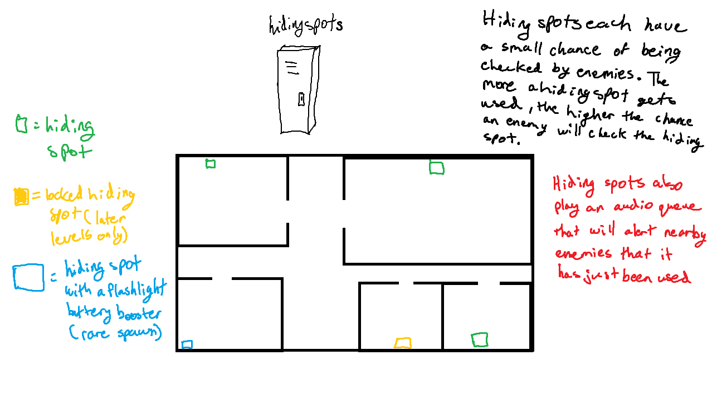

**Room Lock/Unlock Mechanic:**

The room lock/unlock system is designed to increase strategic complexity and vary gameplay across levels. At the start of each level, certain rooms or pathways may be locked, limiting the player’s movement options and forcing them to navigate through riskier areas. Conversely, some rooms will unlock as the player progresses, offering new routes, hiding spots, or access to critical resources like battery packs. The locked rooms also serve to funnel player movement, increasing the likelihood of enemy encounters and creating high-tension moments where players may have to make quick decisions under pressure.

The decision to lock or unlock specific rooms is tailored to each level’s enemy paths and difficulty curve, ensuring that the player must constantly adapt their strategy based on the layout of the environment. In some cases, locked rooms may hold valuable resources, requiring players to find keys to gain access. This adds an additional layer of challenge as players must weigh the potential reward of unlocking a room against the risks involved in retrieving the key or strategic viability of unlocking said room.

**Target Audience:**

This game targets fans of horror games, specifically those who enjoy the tension and strategic gameplay found in games like *FNAF* and *Outlast*. The ideal audience will be between 16+ years of age, with some experience in gaming but not necessarily hardcore gamers. Players who enjoy decision-making under pressure, resource management, and atmospheric horror will find this appealing.

**Visual Design:**

The visual style will be pixel-art with a dark, moody palette to emphasize the horror atmosphere. Lighting effects, such as the player's flashlight and the glow from security cameras, will create stark contrasts between darkness and visibility. Enemy designs will be eerie, humanoid/nightmare-style animal figures with exaggerated and unsettling features. Even though the demo may not fully showcase the game’s aesthetic, mockups of characters, and environment layouts in terms of art design (there's a chance I will finish this project during the course) will give a good sense of the final visual tone.

**Scope of Demo:**

The demo will focus on the core mechanics, showcasing:

* **Flashlight & Battery System**: Players will have a functioning flashlight with a battery that depletes over time to counter lack of visibility and enemies.
* **Camera System**: Security cameras can be accessed, with the feature of night vision to enhance visibility, giving players an advantage but increasing the risk as enemies can move while the player is using the cameras.
* **Enemy AI Pathing**: A simple enemy will roam the map in early levels, while later levels will introduce multiple enemies with more complex paths and behaviors.
* **Hiding Mechanic**: At least one functioning hiding spot where the player can evade enemies, with a counterbalance system where enemies may occasionally check hiding spots and react to the sound of hiding spots being used in proximity.

In terms of level design, the demo will include 5-7 levels, with progressively increasing difficulty, an increasing number of enemies, and more complex room layouts (some rooms locked or unlocked per level).